# Datasheets

## Sitara AM263 MCU

* [Main Page](https://www.ti.com/product/AM2634)
* [Technical reference Manual](https://www.ti.com/lit/ug/spruj17c/spruj17c.pdf?ts=1676503192967&ref_url=https%253A%252F%252Fwww.ti.com%252Fproduct%252FAM2631)
* [MCU Datasheet](https://www.ti.com/lit/ds/symlink/am2634.pdf?ts=1676570365407&ref_url=https%253A%252F%252Fwww.ti.com%252Fproduct%252FAM2634)

## LPAM263 MCU Launchpad

* [Main Page](https://www.ti.com/tool/LP-AM263)
* [User Guide](https://www.ti.com/lit/ug/spruj10c/spruj10c.pdf?ts=1676484965266&ref_url=https%253A%252F%252Fwww.ti.com%252Ftool%252FLP-AM263%253FkeyMatch%253DAM263%2BLP)

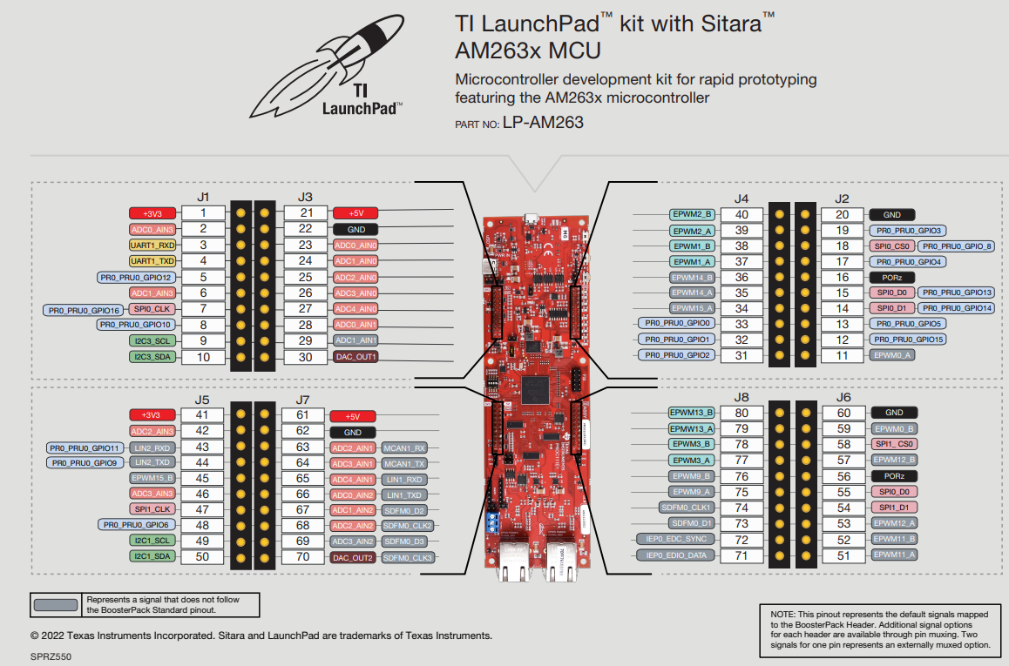

## DRV8323

* [Main Page](https://www.ti.com/product/DRV8323)
* [Datasheet](https://www.ti.com/lit/ds/symlink/drv8323.pdf?ts=1676503922003&ref_url=https%253A%252F%252Fwww.ti.com%252Fproduct%252FDRV8323)

## DRV8323 EVMs

* [BOOSTXL-DRV8323RH](https://www.ti.com/tool/BOOSTXL-DRV8323RH)
* [BOOSTXL-DRV8323RS](https://www.ti.com/tool/BOOSTXL-DRV8323RS)